

Software design Task 4

Bernie Wong

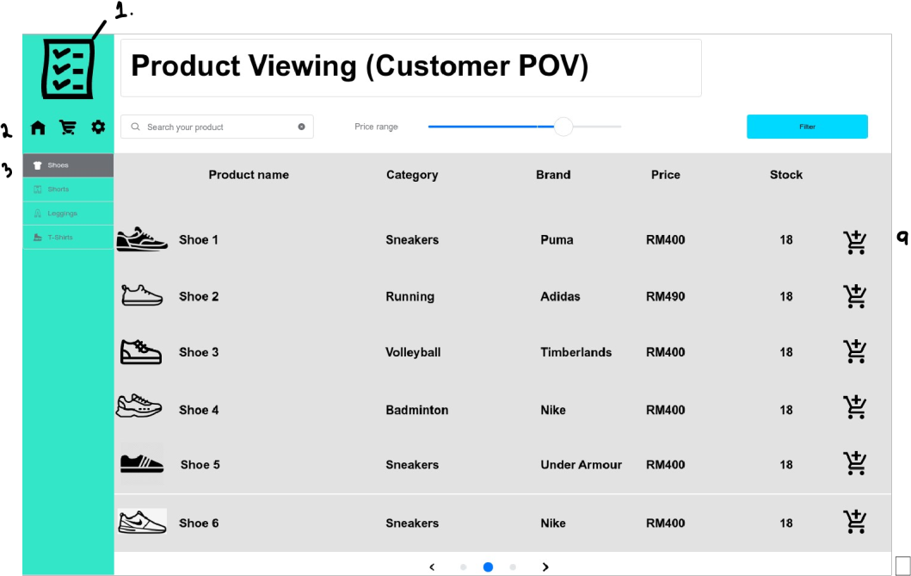

1. Software Icon Logo
2. Customer navigation; homepage, shopping cart, settings
3. Product category list section
4. Page navigation tools
5. Showcasing list of products with details; name, category, brand, price, stock, quantity.
6. Product search function
7. Price range slider for specific budget
8. Filter results
9. Add product to shopping cart

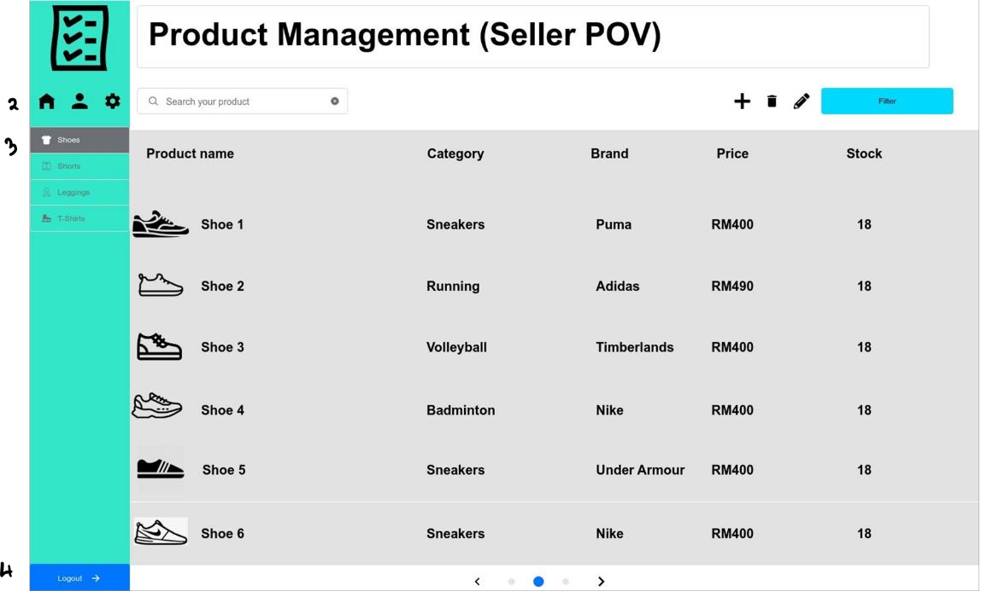

1.

5.8

7.

6.

4.

1. Software icon logo
2. User (seller) navigation; homepage, settings, account page
3. Product category list navigation
4. Logout button
5. Search function
6. Showcasing list of products with details; name, category, brand, price, stock
7. Product modification; add, edit, delete
8. Filter search results
9. Page navigation

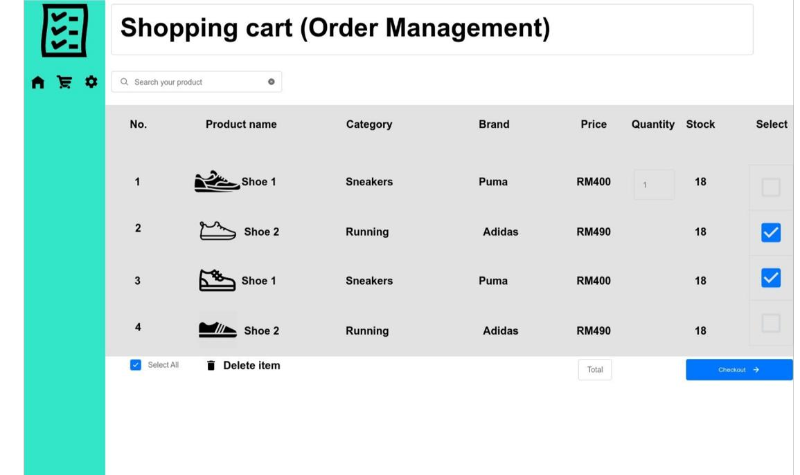

1.

2.

3.

4.

5.

6.

1.

8.

* 1. Customer navigation; homepage, shopping cart, settings
  2. Search function
  3. Showcasing products added in the shopping cart by the customer
  4. Select specific item function
  5. Select all items functions
  6. Delete item from shopping cart function
  7. Total price based on the selected item(s)
  8. Checkout to payment

1. User navigation
2. User section/page navigation; dashboard, products, online store, messages, statistics, orders
3. Greeting message from the system to the user

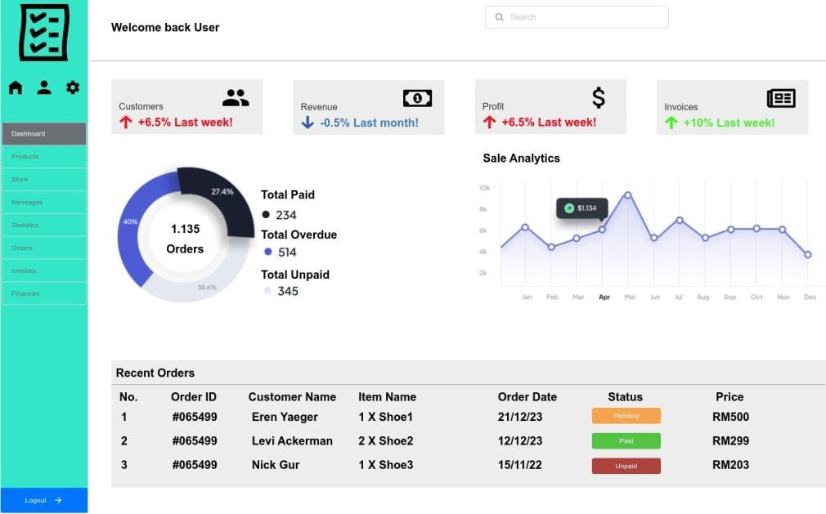

3

.

5.

1.

4.

2.

7.

6.

1. Statistical information for the user
2. Search function
3. Logout button
4. Order information

**Usability Questions**

**Testing for completion and efficiency:**

* **Can you successfully add a new product to the inventory? How easy or difficult was the process?**
* **Can you edit the details of a product, such as the price or name?**
* **Were you able to remove a product from the inventory easily?**
* **Can you successfully add a product to your shopping cart?**
* **Can you select a product and checkout with it?**

**User interface intuitiveness and clarity:**

* **Is the layout and organization of the product management interface clear and easy to navigate?**
* **Were you able to find the necessary fields and options to add/update product information without confusion?**
* **Were you able to navigate different pages such as home page or settings?**

**Search and Filtering effectiveness:**

* **Were you able to find a specific product quickly using the search functionality?**
* **Is there a filter button to filter your search results?**
* **Did the search results accurately match your query?**

**Error Handling & Validation:**

* **Did the system provide clear error messages when you entered incorrect or invalid data while adding/updating a product?**
* **Did the product details page provide all the necessary information, such as images, descriptions, and pricing?**

**Product Details & Visualization:**

* **Were you able to view detailed information about a product easily?**
* **Did the product details page provide all the necessary information, such as images, descriptions, and pricing?**
* **Were the product images clear and of sufficient quality?**